Create an equipment recommendation agent
Exercise 1 - Create the equipment inventory
Create a standalone data source for this exercise.
If you don’t have a SharePoint site, create one before proceeding:
- Go to Microsoft Copilot at https://copilot.cloud.microsoft and sign in with your lab credentials.
- Select the App launcher (⋮⋮⋮) icon, and then select SharePoint. If you don’t see it, select More apps.
- On the left navigation, select Build, and then select Site > Team site.
- If prompted to choose a template, select Standard team, and then select Use template.
- Enter PL7008 Equipment <your initials> as the site name, replacing <your initials> with a unique value.
- Confirm that Privacy settings is set to Private - only members can access this site, leave the other settings as default, and then select Create site.
- If prompted to add members, you can skip adding them and select Go to site. Wait for the new site to open.
- Open the SharePoint site that you use for the exercise, and then select New > List. Under Create from blank, select List.
- Enter PL7008 Equipment Inventory <your initials> as the list name, replacing <your initials> with a unique value, and then select Create.
- Keep the default Title column. Select + Add column and create the following columns:

Column name | Type
Category | Single line of text
BestFor | Multiple lines of text
Location | Single line of text
UnitPrice | Currency
UnitsAvailable | Number
AccessibilityNotes | Multiple lines of text

Title | Category | BestFor | Location | UnitPrice | UnitsAvailable | AccessibilityNotes
Contoso Standard 14 | Laptop | General productivity and hybrid work | Seattle | 950 | 12 | Supports external keyboard, mouse, and two displays
Contoso Performance 15 | Laptop | Data analysis and local development | Seattle | 1,450 | 4 | Supports external keyboard, mouse, and three displays
Contoso Travel 13 | Laptop | Frequent travel and presentations | Chicago | 1,100 | 0 | Lightweight chassis and one external display
Contoso Focus 27 | Monitor | General productivity and document work | Seattle | 320 | 8 | Height-adjustable stand and low-blue-light mode
Contoso Wide 34 | Monitor | Large spreadsheets and side-by-side analysis | Seattle | 680 | 2 | Height-adjustable stand; confirm desk width before ordering
- Select + New and add the following items to the list:

- Copy the SharePoint site address and note the exact list name. You use both values when you configure the connector tool. For example, a site address might be https://contoso.sharepoint.com/sites/sitename.

Exercise 2 - Prepare the equipment policy
- Open a text editor and create a file named contoso-equipment-policy.md.
- Add the following content to the file:
code
# Contoso equipment policy

This fictional policy supports a training exercise.

## General rules

Recommend only equipment that is currently available in the employee's work location. A recommendation doesn't reserve or order an item. If no compliant item is available, state that no matching item is in stock and direct the employee to the IT procurement team.

Ask for the employee's role, work location, primary work scenario, and accessibility requirements before making a final recommendation. Don't infer an accessibility need.

## Laptop standards

- General productivity and hybrid roles use a standard laptop when one is available.
- Data analysts and developers can use a performance laptop when their work includes local data processing, development tools, or large models.
- Frequent travelers can use a travel laptop when it is available in their location.

## Monitor standards

- General productivity roles can use one 27-inch monitor.
- Data analysis roles can use one ultrawide monitor when the employee works regularly with large spreadsheets or side-by-side datasets.
- Confirm desk width before recommending an ultrawide monitor.

## Accessibility and exceptions

Explain relevant accessibility features from the inventory without deciding whether they meet an individual's needs. Direct requests for ergonomic assessments, assistive technology, policy exceptions, or equipment that isn't listed to the IT procurement team at it-procurement@contoso.com.
- Save the file in a location you can access during the exercise.

Exercise 3 - Prepare the supplied skill
- Create another file named equipment-recommendation.md.
- Add the following supplied skill content to the file:
code
---
name: equipment-recommendation
description: Use when a user asks for a laptop or monitor recommendation.
---

# Equipment recommendation

Help a user select approved Contoso equipment without placing an order.

## Required inputs

Before making a final recommendation, collect:

- Employee role.
- Work location.
- Primary work scenario.
- Accessibility requirements, if any.

Ask only for information that isn't already available in the conversation.

## Steps

1. Use the Contoso equipment policy knowledge source to identify the applicable rules.
2. Use the Get equipment inventory tool to retrieve current inventory.
3. Consider only items in the employee's location with UnitsAvailable greater than zero.
4. Compare the eligible items with the employee's role, work scenario, and stated requirements.
5. Recommend one item for each requested category and explain why it fits.

## Decision rules

- Don't recommend an out-of-stock item.
- Don't claim that a recommendation reserves or orders equipment.
- Don't infer accessibility needs or decide whether a feature meets an individual's needs.
- When no compliant item is available, state that result and provide the IT procurement contact from the policy.

## Success criteria

A complete response cites the policy, reflects current inventory, explains the match, and identifies any missing information or required escalation.
- Save the file in the same location as the contoso-equipment-policy.md file so that you can access both files during the exercise.

Exercise 4 - Create the agent
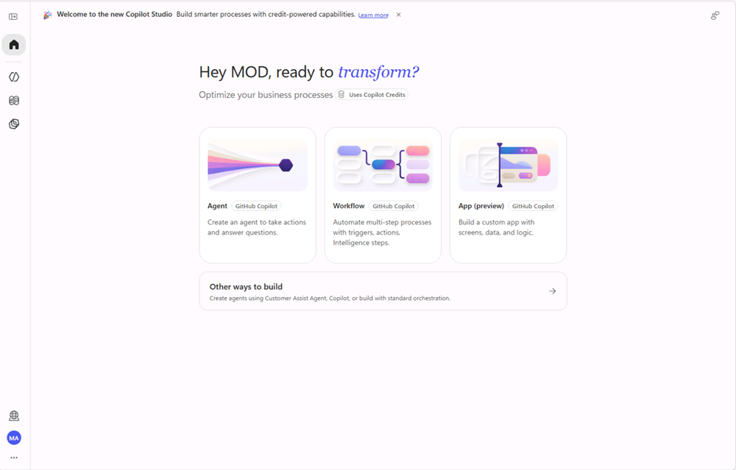
- Go to Microsoft Copilot Studio at https://copilotstudio.microsoft.com/ and sign in.
- Confirm that the correct environment is selected.
- On the Home page, select Agent. Alternatively, select Agents in the left navigation, and then select New agent.
- In the Name field, enter Contoso Equipment Advisor <your initials>.
- If your organization requires a solution, in the upper-right corner, select More options (…), and then select Settings. In Agent settings > Agent details, check the Solution list. If the solution provided for the exercise isn’t already selected, select it and then select Done. If it’s already selected, you don’t need to select Done; close the settings dialog.
- In Instructions, enter the following text:
code
You are the Contoso Equipment Advisor. Help employees understand equipment standards and identify currently available equipment.

Use configured knowledge for Contoso policy. Use tools for current inventory. Cite the source used for each policy statement. Don't invent equipment, availability, prices, policy exceptions, or order status.

Use a concise, professional tone. Ask for missing information before making a final recommendation. For ergonomic assessments, assistive technology, policy exceptions, or unlisted equipment, direct the employee to the IT procurement team.

Don't place, promise, or imply an order. Politely decline requests unrelated to workplace equipment.
- Select Save.

Exercise 5 - Add policy knowledge
- On the Build tab, select the Knowledge section in the components panel to open the Add knowledge dialog.
- Select Drag and drop or click to upload, and then upload contoso-equipment-policy.md.
- Select Add to agent and wait for the upload to finish.
- Under the Knowledge section, select contoso-equipment-policy.md. In the Edit knowledge source dialog, enter Contoso equipment policy as the name and Approved equipment standards by role, work scenario, location, and accessibility need. This source doesn't contain current inventory or stock levels as the description.
- Select Save to apply the changes to the knowledge source.

Exercise 6 - Add the inventory connector tool
- On the Build tab, select the Tools section to open the Add a tool dialog.
- Select Connectors, search for SharePoint, and under SharePoint, select See (x) more to expand the list of available actions.
- Select the Get items action, and then select + Add to create your SharePoint connection.
- In the Tools section, select the newly added SharePoint connector. In Tool details, set the tool name to Get equipment inventory. In Description for AI, enter Retrieves the current Contoso equipment inventory, including category, location, price, available units, intended use, and accessibility notes. Use for equipment availability and recommendation requests. This tool reads inventory and doesn't reserve or order items.
- In the Inputs section, select Custom next to each input and configure the values as follows:
Input | Value
Site address | The SharePoint site address that you copied.
List name | PL7008 Equipment Inventory <your initials>
- Leave all remaining optional inputs unchanged. The list is intentionally small, so the tool can return all exercise items for the agent to compare.
- Keep the completion behavior that lets the agent use the tool results to generate a contextual response. Select Done, and then select Save.
Connector fields can vary by connector version. If the action shows additional required inputs, configure them so that the action returns all items from the exercise list.

Exercise 7 - Test knowledge and the tool
- Select the Preview tab.
- Start a new conversation by entering What is the equipment rule for a data analyst who works with large spreadsheets? and submit it.
- Verify that the response uses and cites the policy. It should explain the performance laptop and ultrawide monitor rules without claiming that either item is available.
- Start a new conversation, enter Which laptops are currently available in Seattle? and submit it.
- If prompted, select Approve to grant the agent permission to use SharePoint. You may need to grant permission more than once.
- Verify that the agent uses the Get equipment inventory tool and reports only laptops with available units in Seattle.
- Start a new conversation, enter Which travel laptop can I get in Chicago? and submit it.
- Verify that the agent reports that no travel laptops are currently available in Chicago and doesn’t recommend the out-of-stock travel laptop.

Exercise 8 - Add and test the supplied skill
- Return to the Build tab and select the Skills section in the components panel.
- Select Upload a skill, upload equipment-recommendation.md, and confirm that the skill appears under Skills.
- Select the Preview tab, start a new conversation, enter Recommend a laptop for a data analyst in Seattle who runs local data models. I don't have any accessibility requirements and submit it.
- Verify that the skill guides the agent to consult the policy, retrieve inventory, and recommend the available performance laptop with an explanation.
- Start a new conversation, enter Help me outfit a new data analyst's home office in Seattle for large spreadsheets. There are no accessibility requirements and submit it.
- Inspect the activity details. The skill’s initial description mentions only a laptop or monitor recommendation, so the broader setup request might not activate it or might produce an incomplete result.
Generative behavior can vary. If the skill activates and produces a complete result, use Plan an approved equipment setup for a new analyst in Seattle as the broader activation test.

Exercise 9 - Refine the skill description
- Open equipment-recommendation.md in a text editor.
- In the metadata section at the top of the file, replace the description value with:
code
description: Use when a user asks for an approved workplace equipment recommendation, compares equipment for a role or work scenario, or plans a laptop, monitor, or complete work setup.
- Save the file.
- Select the Build tab. In the agent’s Skills section, open the uploaded skill, select (…) > Replace, and replace it with the updated file. If the replace option isn’t available, delete the original skill and upload the updated file.
- Return to the Preview tab, start a new conversation, and repeat the home-office setup prompt.
- Verify that the agent gathers any missing information, uses the policy and the Get equipment inventory tool, recommends only available items, and explains why each item fits.
- Start another new conversation, enter How do I bake a loaf of bread? and submit the prompt.
- Verify that the equipment skill doesn’t activate and that the agent states that the unrelated request is outside its scope.

